|  |  |  |
| --- | --- | --- |
| **Philadelphia Federation of Teachers Health & Welfare Fund & Union** | **Evaluation Requested By**: PFT H&W Fund & Union **Page 1 of** | |
| **Date Inspected**: 11/22/2013  **Initial Inspection?** **☐**  **Follow-Up Inspection?** ☑ | **Inspected by:** Jerry Roseman M.Sc. I.H.  **Others Present? Y**  **Name[s]:** Brian Joseph OEMS-KEM |
| **IEQ Evaluation & Inspection Summary Report – Lowell E.S.** | **Date Report Issued**: 11-25-13  **Report Provided To:** Arthur Steinberg, PFTH&W Fund | Photos Attached**: ☑**  Sketches Attached: **☐** |
| **Building Name:** Lowell E.S. **Building Address:** 5th & Nedro Streets **Phone #:**  **Main Contact[s]:** Amy Schlein-Kaufmann [PFT Rep]; Mr. Lugo [Principal]; Mr. Chisolm [B.E.] | | |
| **Inspection Overview:** This evaluation was requested by the PFT & conducted in response to ongoing and reported problems from building occupants. Information was provided [and observations/measurements made] about:    [1] Respiratory illnesses and related symptoms and breathing disorders from school staff – [also including students];  [2] Significant, ongoing and long-documented thermal control problems primarily associated with the original building [confirmed during inspection];  [3] Pest management and general cleanliness issues, especially in the Sherman Annex [confirmed by observation];  [4] The presence of dozens of single &/or double hung [and similar] aluminum clad windows - “unguarded” and unprotected posing a serious safety risk - are present and accessible to staff and children in the original building [confirmed during inspection];  [5] Ongoing leaks from classroom unit ventilators [CUVs] during AC season & possibly other sources, particularly in the Sherman Annex;  [6] Foul/offensive odors and lack of exhaust ventilation in Sherman Annex bathrooms;  [7] Damaged plaster/peeling lead paint in numerous areas of the original building    **It should be noted that many of these problems have been previously [and repeatedly] documented with evaluations conducted in 7/2011, 10/2012, 12/2012, 1/2013, & 4/2013.**  **The SD discontinued it’s environmental action team [E.A.T.] & related oversight approaches at Lowell approximately 2-3 years ago, contributing to increased IEQ problems and concerns & inadequate coordination, collaboration, accountability & control of IEQ management at this location** | | |
| |  |  |  | | --- | --- | --- | | **Room – Area Inspected** | **Relevant Observations, Findings & Measurements** | **Comments-Recommendations-Informational Request** | | Original Bldg.  Building Wide Issue | Thermal control problems were documented and reported throughout the old building – confirmed by all occupants including Principal & B.E. - Temperatures of 83 F – 90 F were measured in several areas during our inspection | 1. Consider installing some type of manual control valve at each radiator for better thermal control in specific areas/rooms;  2. Perform a “steam trap” evaluation & repair & replace defective steam traps as required | | Original Bldg.  Building Wide Issue | Dozens of unguarded & dangerous window conditions were documented as present throughout the building – [Representative photos provided below] | 1. Immediately address dangerous windows by placing guards/screens on all windows accessible/reachable by occupants;  2. Provide status and update about remediation | | Original Bldg.  Building Wide Issue | Damaged paint [assumed to be lead containing] & plaster were observed in numerous areas including in some classrooms [eg. 311, 312, 108], hallways, stairwells, 2nd floor women’s restroom and other locations [Representative photos provided below] --- Some areas had not been repaired despite being identified in previous reports on | 1. OEMS rep. characterized all damaged areas – All identified areas should be repaired following lead-safe procedures and precautions;  2. A root cause evaluation should be undertaken to determine the source[s] of the interior damage and effective repair implemented | | Room 107 | **Damaged asbestos-containing pipe insulation in closet** | **IMMINENT HAZARD & needs to be immediately addressed** | | Room 107 | Radiator guard screens dislodged and loose | Reattach/securely fasten screens at radiators | | Sherman Annex  Building Wide Issue | Pest management and control issues continue– occupants reported rodent droppings on floors, desks, and other surfaces – very dirty carpets likely contaminated with rodent droppings & urine [photo documentation provided] | 1. Upgraded pest management response required on an ongoing, consistent & routine basis – in coordination with the FAC, building engineer and cleaning staff – additional custodial staff required;  2. Pest Management issues should be managed using the building committee-E.A.T.-type approaches | | Sherman Annex - Bathrooms | Foul and offensive odors from bathrooms in Sherman Annex again reported – **Repeat issue** | 1. Evaluate bathrooms for exhaust fan operation;  2. Evaluate the potential for plumbing/drainage issues to be causing problems; | | Sherman Annex  Building Wide Issue | Classroom unit ventilators [CUVs] were reportedly still leaking during AC system resulting in moisture, dampness and standing water on floors and impacting surfaces. Leaks from 2nd floor CUVs seem to be the cause of continuing and re-occurring damage to ceiling tiles | 1. Evaluate all CUVs in the Sherman Annex to determine operational and maintenance problems and needs with a particular focus on water leaks and condensate system components;  2. Effect repairs to CUVs as required | | Building Wide – Both Old Bldg.& Sherman Annex | Stained ceiling tiles were observed in numerous areas of the building including in the Nurse’s office, and other sections of the school | 1. Immediately replace all water damaged/stained ceiling tiles;  2. Evaluate and address the root causes for the ongoing and/or repeat problems with water intrusion, dampness and moisture | | **IEQ Dashboard Summary – Lowell** | The most recent IEQ Dashboard summary, available to us for Lowell indicates approximately 100 observed deficiencies in need of corrective action – although a number of these issues [especially the replacement of ceiling tiles that were water damaged/stained have been done, a number of significant and large scale problems remain – a review of the IEQ Dashboard is recommended | Review the 10/18/13 IEQ Dashboard of “Open” Items and implement corrective actions recommended by OEMS over the past 2+ years – specific line items are referenced below:  **Line Items: 569, 570, 571, 575, 583, 598, 599, 600, 601, 602, 603, 605 - these corrective actions should have been implemented – if not, that should now occur** | | | |

**Inspection Summary**

**[1] Evaluation Overview -** The 11/22/13 inspection was jointly conducted with Brian Joseph [OEMS-KEM]. He characterized the current status – area-by-area - of what were the approximately 75-100 still “open” items remaining on the most recent IEQ Dashboard [i.e. from inspections conducted between 10/2011 – 4/2013]. Summary information/status should be provided.

**[2] Thermal-Automatic Temperature [ATC] Control Problems** **– Original Building** – These issues have been documented for years and have been continuing with little/no improvement – in addition to comfort and educational programming impacts associated with temperature extremes, there is significant financial cost associated with unnecessary energy losses & inefficiencies. Manual controls, evaluation of steam traps and other system components and heating system operation should be promptly conducted.

**[3] Paint & Plaster – Original Building –** There were several areas in which peeling and chipping lead-containing [assumed] paint and damaged plaster were present primarily throughout the original building – these areas need prompt remedial attention [using lead-safe, dust control practices and procedures] and a root-cause assessment should be conducted.

**[4] Asbestos Hazard – Room 107 –** As included above, significantly damaged asbestos-containing pipe insulation [ACPI] was observed in the closet of this room [photo documentation provided]. It was understood that this condition constituted an **imminent hazard**  and that the area would be immediately restricted and abated – confirmation should be provided

**[4] Window Safety – Original Building –** As described, more than 2 dozen aluminum clad windows, of the type previously documented to fail catastrophically and typically without warning [serious incidents at both Creighton and Fox Chase E.S.s among others] are present and need immediate attention to prevent potentially serious safety hazard and risk to students and staff.

**[5] Classroom Unit Ventilators – Sherman Annex –** The CUVs throughout this part of the building continue to present problems with leaking condensate pans and related system components resulting in moisture, dampness and water damage to floors, carpets and other materials and surfaces. A root cause evaluation needs to be conducted and an O&M program should be immediately implemented to address these issues;

**[6] Carpet – Sherman Annex –** Carpeting throughout classrooms is old, stained and dirty. Given the pest/rodent problems as reported and documented it is very likely that carpets are regularly impacted by rodent droppings, urine and other microbial contaminants. Previous inspection findings have documented these same conditions and specific control recommendations including replacement of carpet and steam cleaning on a regular and ongoing basis have been previously provided. These recommendations should be immediately implemented

**[7] Water Stained/Damaged Ceiling Tiles – Building Wide –** water damaged and stained ceiling tiles were observed throughout the buildings. These tiles should be immediately replaced and root causes evaluated and addressed

**[8] Information Sharing**

* All reports, summaries and information related to remediation should be provided to PFT H&W Fund/Union representatives & building occupants in a timely and ongoing manner;
* An E.A.T. should be restarted at Lowell to facilitate an effective joint and accountable process for working in a collaborative way to solve ongoing IEQ-related problems and issues;
* Critical review and follow-up related to root causes and previous evaluations and a lessons-learned approach should be implemented;
* A transparent, and collaborative process should be implemented, involving all stakeholders, customers and participants to facilitate an effective response to addressing health and safety concerns at Lowell

**PHOTO LOG -** **Selected & Representative** **Photos**

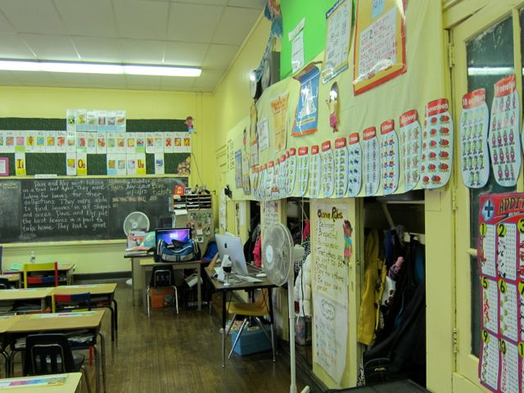

**J. Lowell E.S. – 11/22/13 – Room 101**

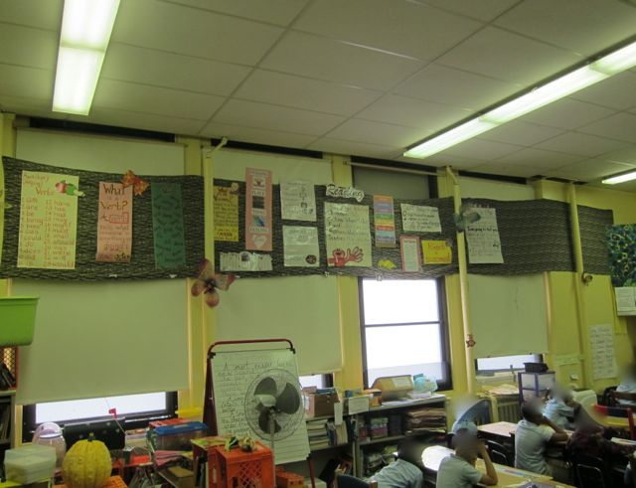

**J. Lowell E.S. – 11/22/13 – Classroom 101 – Close-Up [showing Ed. Materials teacher told to remove]**

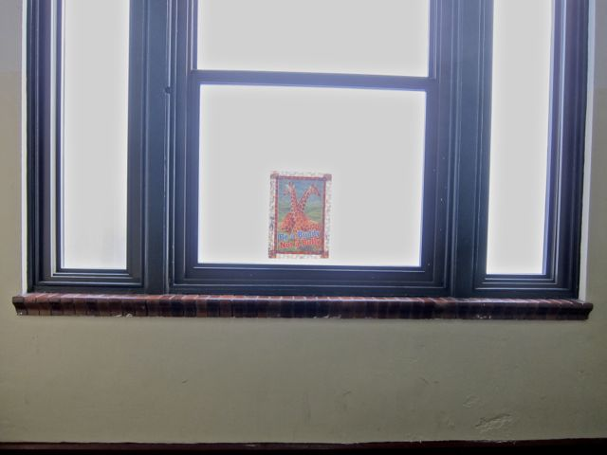

**J. Lowell E.S. – 11/22/13 – Lawrence St. Stairwell – Landing [1st-2nd floor] – Unguarded windows**

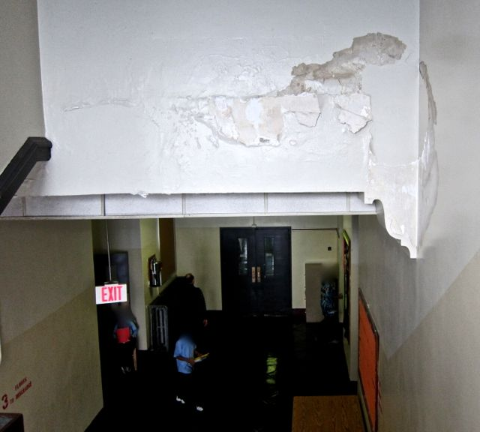

**J. Lowell E.S. – 11/22/13 – Lawrence Street Stairwell Landing – Damaged Paint [assumed lead] & plaster**

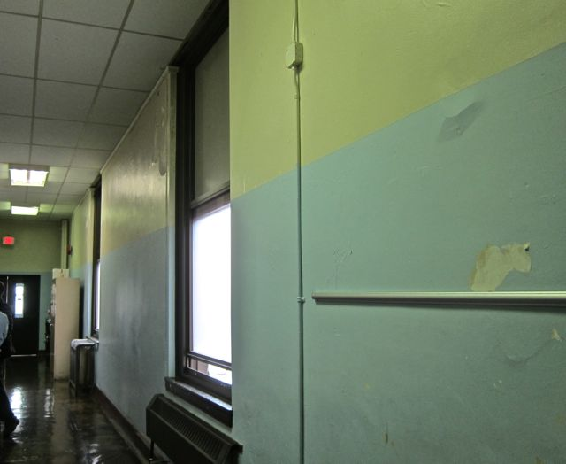

**J. Lowell E.S. – 11/22/13 – 3rd Fl. Hall [near 301-302] Damaged paint [assumed lead-containing] & unguarded windows**

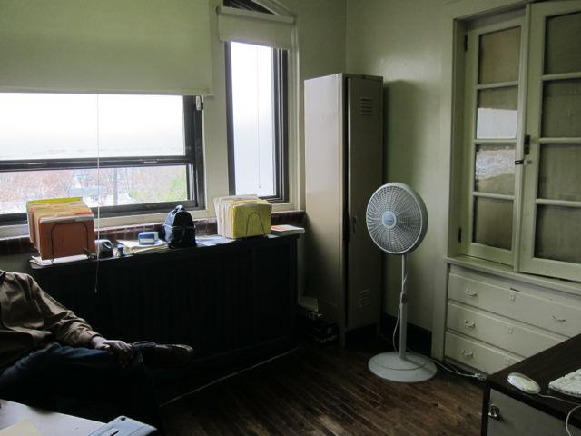

**J. Lowell E.S. – 11/22/13 – Classroom 312 – Counselor’s Office – very elevated temp. & unguarded window**

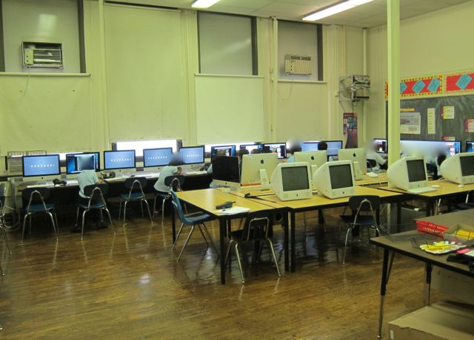

**J. Lowell E.S. – 11/22/13 – Room 202 – Computer Lab – 28 Computers – 85+ deg. F measured**

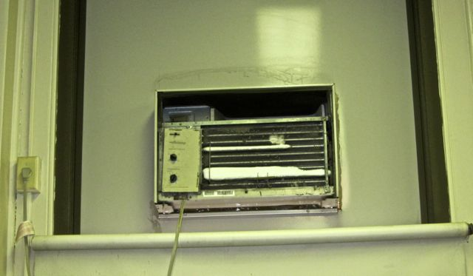

**J. Lowell E.S. – 11/22/13 – Room 202 – Computer Lab – Frozen AC [unit still “on” and operating]**

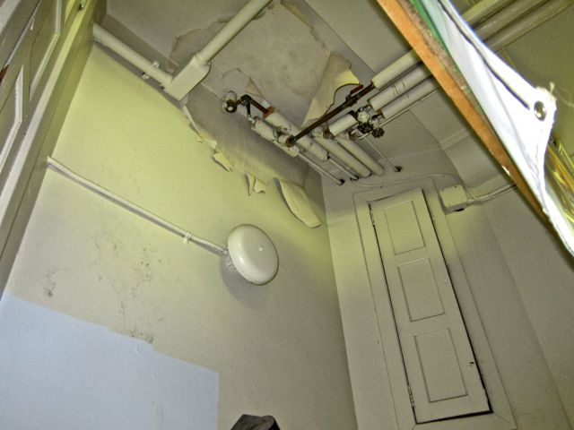

**J. Lowell E.S. – 11/22/13 – 2nd floor hallway above sink -- Damaged paint [assumed lead] & plaster**

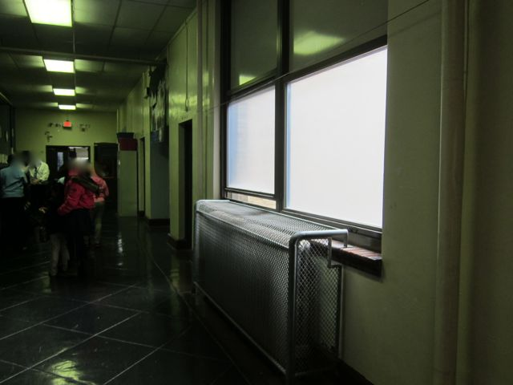

**J. Lowell E.S. – 11/22/13 – 2nd floor hallway – unguarded and accessible windows**

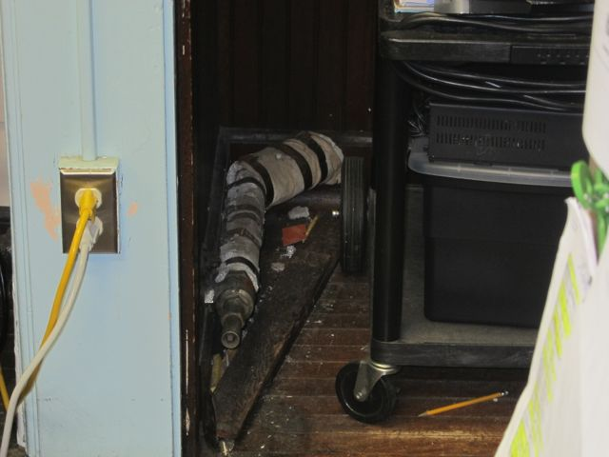

**J. Lowell E.S. – 11/22/13 – Room 107 Closet – Damaged Asbestos-Containing Pipe Insulation [ACPI]**

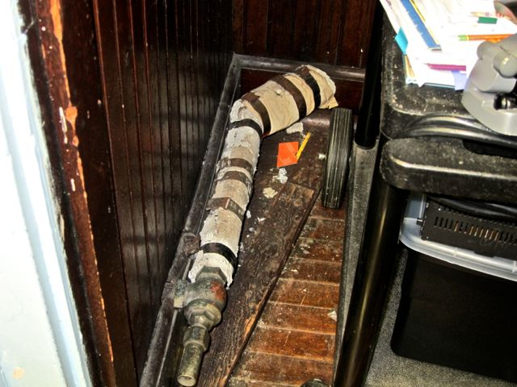

**J. Lowell E.S. – 11/22/13 – Room 107 Closet – Damaged ACPI [Close-up]**

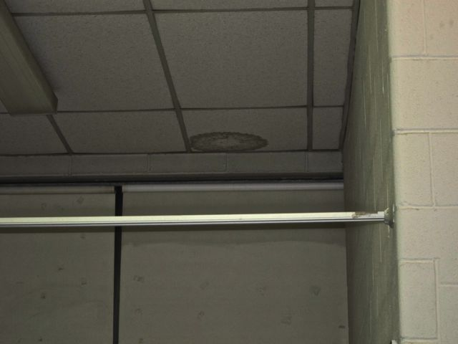

**J. Lowell E.S. – 11/22/13 – Nurse’s Office – Water stained/damaged Ceiling Tile**

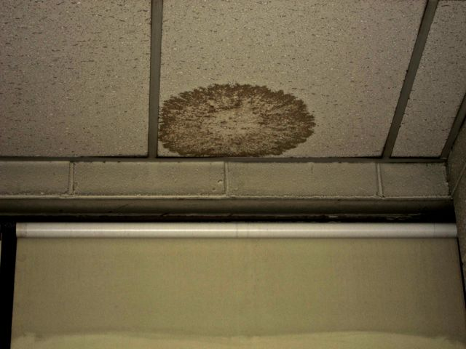

**J. Lowell E.S. – 11/22/13 – Nurse’s Office – Water stained/damaged Ceiling Tile [close up]**

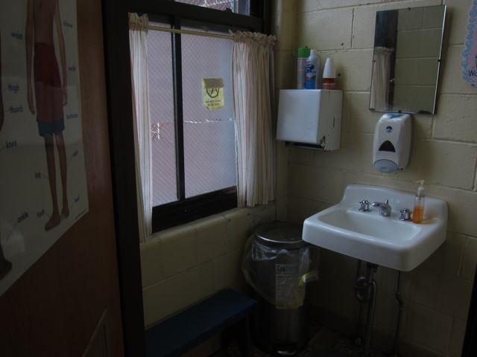

**J. Lowell E.S. – 11/22/13 – Nurse’s Office – Unguarded windows**

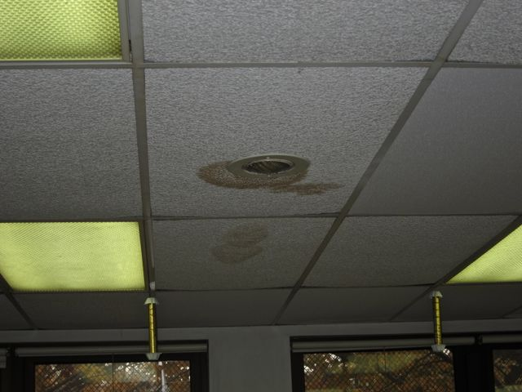

**J. Lowell E.S. – 11/22/13 – Sherman Annex – Classroom S-12 [Repeat Occurrence Likely]**

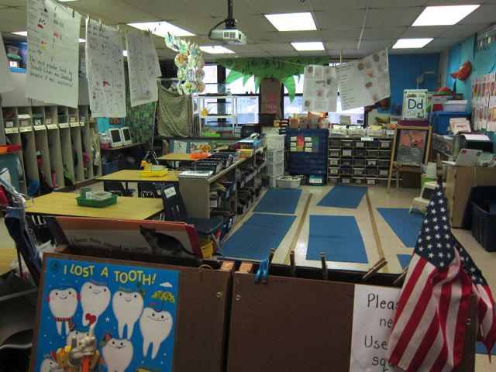

**J. Lowell E.S. – 11/22/13 – Sherman Annex – Classroom S-11 – Dirty carpet pictured**

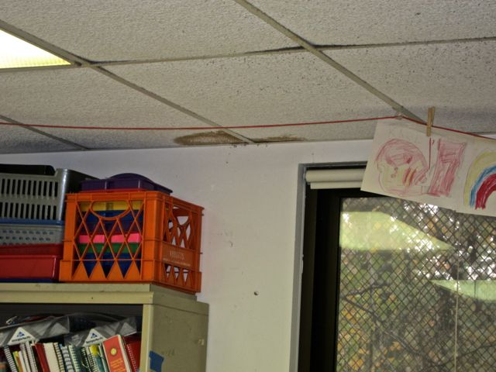

**J. Lowell E.S. – 11/22/13 – Sherman Annex – Classroom S-11 – Water Damage/staining to ceiling tiles – new occurrence reportedly from CUV above**

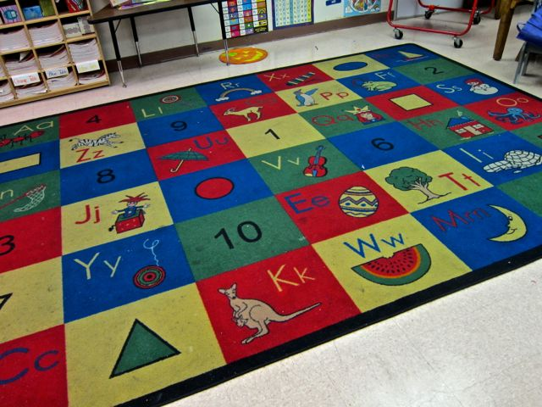

**J. Lowell E.S. – 11/22/13 – Sherman Annex – Classroom S-15 – Dirty, Stained 8’ x 12’ carpet**

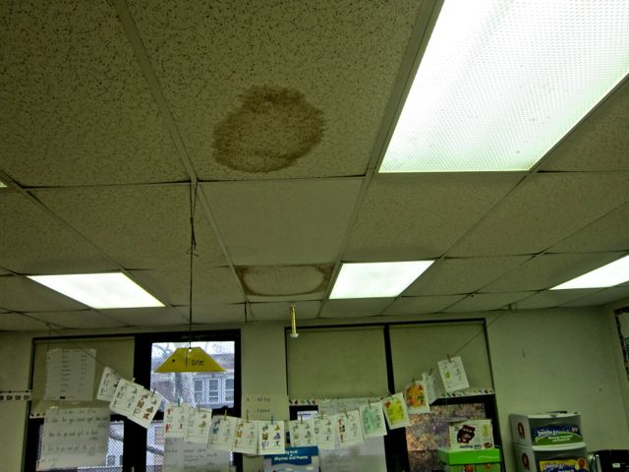

**J. Lowell E.S. – 11/22/13 – Sherman Annex – Classroom S-16 Water damaged/stained ceiling tile**

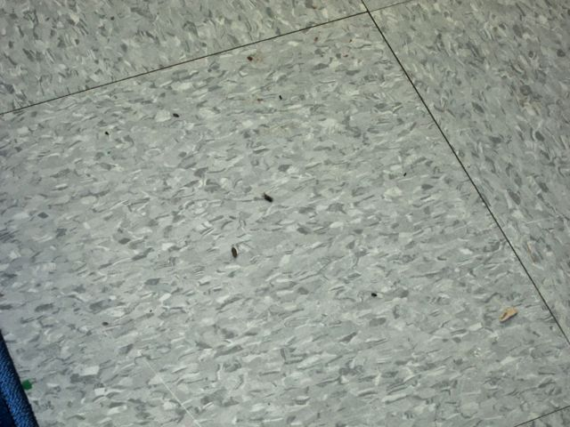

**J. Lowell E.S. – 11/22/13 – Sherman Annex – Classroom S-15 – Mouse droppings on floor – middle of rm**

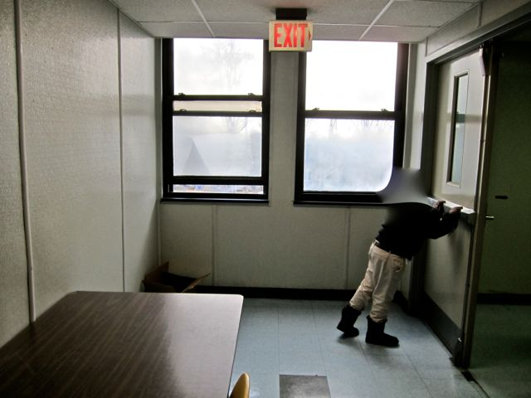

**J. Lowell E.S. – 11/22/13 – Sherman Annex – 2nd floor hall – unguarded windows accessible to young children**